ARCHICAD 20 ‘Array Parametric Lock’ Issue

[Overview]
- In the GDL editing window, when creating an Array Parametric option, the Value field becomes locked.

[Test Environment]
- ARCHICAD 20 INT 4009

[Test Object]
- [SAMPLE] Array Parameter Lock 20.gsm

[Parameter]
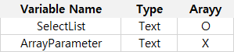

[Error Conditions]
- Create 'SelectList' parameter
  - Text Type parameter
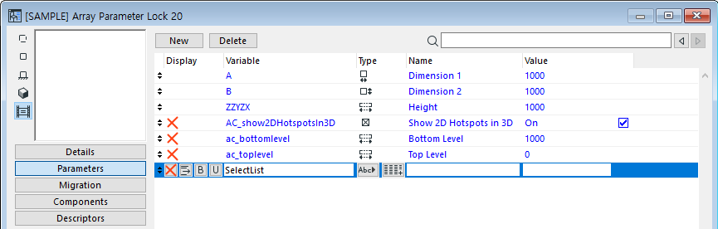

- In the 'Parameter' script window, enter values for “SelectList”
  - values "SelectList" "A", "B", "C"
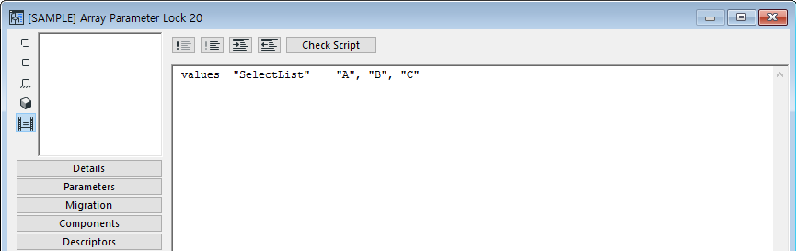

- Check to see if the Values for SelectList parameter works
  - Works correctly
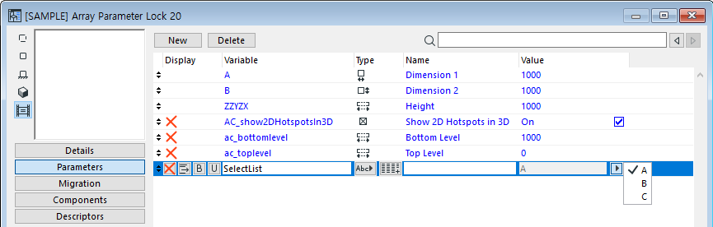

- Create 'ArrayParameter' parameter
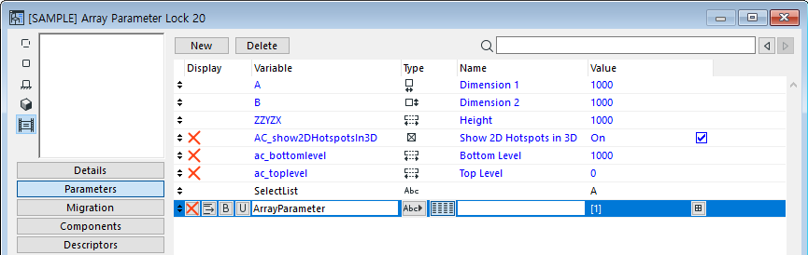

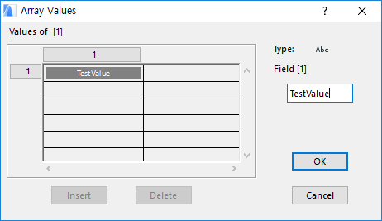

- Previously created 'SelectList' Parameter becomes locked
  - It looks as if a 'Lock' script has been applied
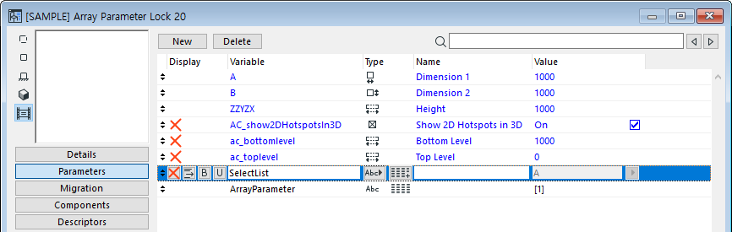

[Comment]
- Error occurs when ArrayParameter is created regardless of the number of values / array parameters created.
- The error occurs when ArrayParameter is created regardless of the order in which the ArrayParameter is created.

